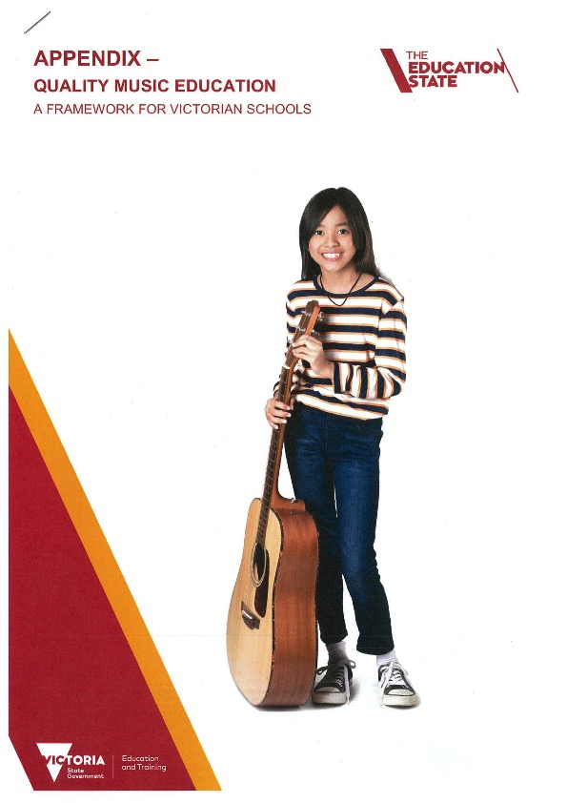
QUALITY MUSIC EDUCATION
A FRAMEWORK FOR VICTORIAN SCHOOLS

About the framework
The purpose of this Quality music education framework (the framework) is to:

- demonstrate the importance of music education
- assist school leaders to identify what needs to be in place for delivery of a high quality music program
- provide access to quality music programs.

This framework complements the framework for improving student outcomes
Evidence is strong and consistent that in addition to the intrinsic value of learning about music, exposure to quality music education provides students with a range of developmental benefits, including positive social, cultural and educational outcomes (Arts Education Partnership 2011, Caldwell 2012, Parliament of Victoria 2013, Hallam 2015). ​

This framework provides an evidence base to support Victorian school leaders to plan and strengthen the effectiveness of their school music programs by giving consideration to six characteristics of quality music education:

- engagement
- excellence
- creative and active
- student-centred learning
- progression
- authenticity.

A quality whole-school music program needs to meet the diverse needs of each school and will differ across schools depending on their needs. The six characteristics identified in this framework will be consistently present.

This framework complements the framework for improving student outcomes, which uses the latest research on student learning and global best-practice to assist schools to focus their efforts on key areas that are known to have the greatest impact on school improvement. In particular, it supports the priority areas of excellence in teaching and learning, positive climate for learning, and community engagement in learning.

This framework also aligns to the Victorian Early Years Learning and Development Framework, Marrung: Aboriginal Education Plan 2016-2026, and the Victorian Curriculum F–10.

Strengthening the design and delivery of music programs will achieve positive benefits for students, schools and the community through:

- increased opportunity for Victorian children and young people to participate in quality music education
- improved capacity and confidence of teachers to deliver quality music education
- increased access to music programs for students in disadvantaged school communities across Victoria
- increased pride and confidence in schools
- increased awareness of the value of music education among school leaders and communities.

As in other learning areas, engagement in music education may or may not lead to a post-school professional pathway. However, involvement in quality music education provides an enriched learning environment and supports improved learning outcomes across curriculum areas.

Characteristics of quality music education

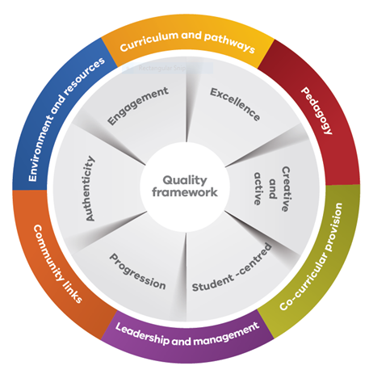

This framework provides an evidence base to support Victorian school leaders to plan and strengthen the effectiveness of their school music programs by giving consideration to six characteristics of quality music education.

This should be read in conjunction with the suite of high impact teaching strategies for excellence in teaching and learning, which have been developed to support schools to reliably increase student learning.

Engagement
A student’s engagement with music education occurs across three dimensions:

- behavioural
- emotional
- cognitive.

In general terms, a student demonstrates engagement when they:

- participate in all areas of the school including academic, social and extracurricular activities (behavioural engagement)
- feel included in the school and have feelings of belonging to the school (emotional engagement)
- are personally invested in and take ownership of their learning (cognitive engagement).

Characteristics of strong student engagement with music education include active, equal and sustained participation, excitement and inquisitiveness. An engaged student enjoys the majority of their musical experiences and feels proud of their achievements while also experiencing the challenges and frustration inherent to learning any new skill.

Teachers should work closely and have a positive working relationship with students so they can:

- take part in rewarding practice sessions
- are confident to perform
- are creative
- can take responsibility for their own learning.

Students are more likely to engage positively when exposed to:

- learning experiences that are rich and varied
- different and diverse musical traditions and styles from a range of historic, social and cultural contexts.

Excellence
Excellence means:
- students are able to demonstrate progress in their learning against the Arts music achievement standards of the Victorian Curriculum F–10
- students make progress in their musical understanding because of high expectations for good quality music-making
- students are able to create and express their own musical ideas that show an understanding of how pitch, duration, dynamics, timbre, texture and structure work together
- schools provide opportunities for student performance
- schools celebrate and value student achievement in music.

Creative and active
Practical music-making is at the heart of all musical learning:
- Effective teachers emphasise developing strong aural skills to help students build the capacity to respond musically in all their music-making.
- Schools give students every opportunity to experiment with instruments and voices and to experience making music with others.
- Students develop an appreciation and understanding of music through active involvement as creators and performers of, and listeners to, music from a diverse range of styles, traditions and cultures.
- There is an atmosphere of collective learning, with teacher and students supporting each other to develop and excel.

Student-centred learning
This involves the wider context of students’ lives, including their cultural needs and identities:
- Student-centered learning involves teachers designing and delivering activities appropriate to the musical and other learning needs of students.
- Teachers review and adapt activities over the course of lessons and programs according to how students are responding.
- Effective educators genuinely take into account students’ musical interests outside of school in the design and delivery of music programs.
- Lessons are inclusive, with all students participating in a range of musical activities.
- Learning experiences are rich and challenging for all students, helping them learn and grow in a variety of ways.
- Schools and teachers seek and respond to students’ views, enabling students to develop ownership of their learning and a sense of belonging in the music program.

Progression
Schools measure learning progress against standards of excellence and achievement and a student’s personal mastery:
- Teachers give regular, structured feedback in response to student practice, providing advice and learning opportunities to facilitate improvement.
- Students identify their own improvement pathways, both individually and together with their peers, with encouragement from teachers.
- Students develop their skills and knowledge through practical music-making informed by accurate assessment.
- Teachers facilitate students’ holistic understanding across all areas of musical activity over time.
- Through formative assessment, teachers listen to students’ musical responses and support them to correct any errors or misconceptions by modelling and precise explanation.
- Frequent recordings help students develop their listening and self-assessment skills.
- Schools identify the steps to achieve expected standards so that teachers and students are clear about what is expected, and students understand how to build their skills and knowledge.

Authenticity
The music teacher recognises and nurtures students’ musical development as well as their wider understanding of what it means to be a musician and the many reasons people make music:
- learning experiences are relevant for students
- tasks are contextual, purposeful and genuine and respect cultural traditions.
Other indicators of authenticity in music-making are the use of innovation, imagination and creative thinking, as well as the relationship between a work and contemporary issues and events.

Factors supporting quality music education
Read the following information in conjunction with the Victorian Curriculum F-10
The factors supporting quality music education programs align with the framework for improving student outcomes state-wide priorities that are proven to have strong bearing on the effectiveness of a school. In particular, it reflects the priorities of excellence in:
- teaching and learning
- positive climate for learning
- community engagement in learning.

More information on the framework for improving student outcomes

Curriculum and pathways
Successful quality music education occurs when the music education program is a part of the whole-school curriculum plan. Schools regularly review this program to ensure continuous improvement. This aligns with the framework for improving student outcomes priority area of excellence in teaching and learning.
A quality music education program includes:
- providing scope for students to achieve above expected standards
- developing students’ appreciation and understanding of music from diverse styles, traditions and cultures
- allowing students to be music creators, performers and appreciators
- ensuring music-making is part of the wider context of students’ lives
- ensuring students have a say in the program, encouraging a sense of student ownership of learning
- ensuring it is interactive, incorporates frequent and varied performance opportunities in and outside class time, enables students to perform in the community, follows pathways to further study and music-making beyond school and uses digital technologies to create, collaborate and record.

Research shows that learning music has a significant impact on the cognitive, emotional, motor, social and personal development of students.

As a result of quality music education students should experience many benefits, including:
- an ability to manipulate, express and share sound as listeners, composers and performers
- a love of music and increased understanding of music and music-making
- a willingness to engage with diverse musical traditions and styles
- skills using digital technologies to create, collaborate and record
- the development of positive social interactions, resilience, teamwork and problem solving.

Pedagogy
Quality music education requires committed, inspiring and skilled teachers. Teachers clarify and reinforce the intent of each lesson and program, as well as their expectations of students. They demystify and clearly explain musical processes, setting up an environment where students feel confident to experiment and have a go.
Leading teachers planning quality music education programs need to be aware that highly effective music teachers are able to:
- encourage positive student-teacher relationships and that students are trusted and given the confidence to perform, be creative and take risks in a supportive, encouraging, and non-threatening environment. This is also achieved when teachers make learning intentions clear and adapted to an individual student’s needs and abilities
- show students how to make connections between their music and the music of others, including a broad range of established composers and performers
- regularly monitor student progress, provide regular assessment and feedback, clearly communicate what success looks like and celebrate success. The teacher also has an understanding of a student’s starting point and delivers activities appropriate to their musical and other needs
- have high expectations of musical excellence by providing high quality musical education opportunities, setting clear goals and enabling students to strive for and make progress above expected or above standards
- build their own capacity as teachers through professional learning, peer networks, consultation with school leaders and an ability to share practice with other teachers
- be reflective and adaptable through reviewing and adapting teaching activities according to how students respond, and have the capacity to take time out for self-evaluation.

Co-curricular provision
Vocal and instrumental programs and lessons that occur outside regular class time are an integral part of an effective school music program. These activities extend and enrich students’ musical experiences and should be encouraged and supported.

Leadership and management
School leaders planning quality music education need a clear vision and documented plan for the development, provision and review of music programs in the school. This process is consistent with the framework for improving student outcomes, and in particular the priority area of professional leadership.
The leadership team needs a sound understanding of the:
- school’s music program
- key features of effective teaching and learning in music
- student progress and achievements
- the program’s strengths
- areas for improvement.
Leading teachers participating in lesson observations can further develop understanding and review programs. Leadership teams also need to provide opportunities for teachers to share their practice and knowledge and provide access to professional learning.

Community links
Partnerships and collaboration with the community and music industry organisations strengthens the quality of music education in schools. Schools should encourage students to attend community musical events and music-making activities.
They should also encourage students to perform at community music events or with community groups as a powerful way to supplement music programs and bring more music to the school culture. In building a successful program, leadership teams should also encourage teachers to connect with a network of experienced music teachers in other schools or their local area.
These activities relate to the framework for improving student outcomes priority of community engagement.

Environment and resources
Schools should ensure planning considers physical factors in delivering music education including:
- the student to teacher ratio
- appropriate music spaces
- any need for considering music spaces in any future building development planning
- planning budgeting for any future music equipment, including digital technologies.

Power and impact of music education
According to the highly regarded researcher Hallam (2015), effective music programs for children and young people are interactive and enjoyable and they also provide opportunities for:
- developing new skills and performing
- acquiring cultural capital
- developing interpersonal bonds and solidarity in pursuing shared goals
- ongoing intensity and frequency of contact
- developing mutual respect
- recognition and rewards for excellence.
Hallam found that successful music programs need to incorporate group work, opportunities for performance and a broad-based curriculum that includes activities related to pitch and rhythm, singing, instrumental work, composition and improvisation and the reading of notation.

There is growing evidence that shows active music-making can enhance a number of non-musical skills. Musical training (i.e. learning an instrument) has positive effects on:
- verbal learning and retention abilities
- literacy
- spatial reasoning
- some elements of executive functioning.
The benefits associated with learning an instrument are not apparent from participation in a choir or ‘music appreciation lessons.’ The development of creative skills is dependent on the nature of the musical engagement and improvising, in particular, has a positive effect.
Although research shows that a child’s socio-economic background can have an impact on the take-up of musical activities, there is evidence to support the relationships between musical training and intelligence regardless of family background.
Research has also found that high-quality musical activities enhance:
- aspirations
- motivation
- attitudes towards school
- attendance for disadvantaged students.
High quality music programs with a sense of student ownership, that are relevant, connected to a student’s culture and involve active music-making, have been found to have a positive impact on disaffected learners, resulting in:
- a greater connection with the school community
- improved self-efficacy and self-concept
- increased motivation and general attainment
- improved behavior
- better positive identity.
‘Taken together, the evidence suggests that music can be a vehicle for re-engaging young people in education and supporting those who are at risk in making changes in their lives. The context within which the projects operate is important in their success as are the musical genres focused on and the quality of the musical facilitators.’ (Hallam 2015)
There is powerful evidence that participating in group music-making:
- supports social cohesion and contributes to feelings of social inclusion
- supports social inclusion of newly arrived migrants and refugee students at school and in the community
- increases parents’ attendance at cultural events
- improves self-esteem and reduces behavioural problems and aggression
- enhances peer relationships and working cooperatively
- improves social skills, cooperation, teamwork and communication
- improves confidence and resilience.

Participation and presentation
Thomas Turino’s (2008) categories of participatory and presentational music are particularly useful in considering quality in music education, and being inclusive. Turino defines participatory music as ‘artistic practice in which there are no artist-audience distinctions, only participants and potential participants performing different roles, and the primary goal is to involve the maximum number of people in some performance role’.
In contrast, presentational performance ‘refers to situations where one group of people, the artists, prepare and provide music for another group, the audience, who do not participate in making the music’.
Participatory music-making is successful when it includes a proper balance between inherent challenges and skill level for all participants regardless of their previous musical experience.
Turino also notes that people tend to return to activities that produce intense concentration and enjoyment (flow) and as they do so, their skill levels increase, requiring activities that have continually expanding and achievable challenges.
The aim of music education should be to maximise participation and engagement for all students of all levels of prior musical experience rather than focusing on the musical outcomes for a limited number.
Most teachers are the products of the music academy where presentational music-making is privileged (‘performing canonised music from notation, for seated, captive audiences’, Randles et al., 2015, p. 61), and this is reflected in the way in which music education (largely performance-focused) is conceived of in schools.
The repertoire used is frequently culturally distant from the general school population and there is little contribution in determining musical content from the students. This is a tradition that is centuries old, and there are students who thrive in this model, heading for a career via the academy.
The majority of students in secondary schools now, however, are not part of the elective music classroom or co-curricular music-making. A focus on engagement and participation could significantly enhance the profile of music in all schools for all students.
The national review of school music education (NRSME) (see below) noted this focus on engagement and participation.

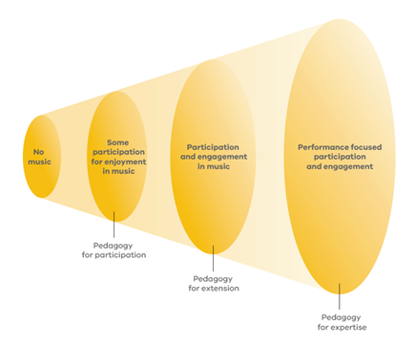National review of school music education (2005)

The findings of the NRSME (2005) remain as relevant today as they were in 2005, and are consistent with the literature generated in subsequent years.
This framework incorporates key ideas from the following NRSME quotes.

Key factors that contribute to a quality music educationExcellenceParticipation, enjoyment and engagement

References
Arts Education Partnership (2011). Music matters: How music education helps students learn, achieve and succeed. Washington DC.
Arts Council of England. (2015). Using quality principles in work for, by and with children and young people
Barrett, M. & Bond, N. (2015). Connecting through music: the contribution of a music programme to fostering positive youth development. Research Studies in Music Education, 37(1), pp. 37–54.
Caldwell, B. (2012). Transforming education through the Arts. Routledge.
Department for Education. (2011). National Plan for Music
Department of Education and Training. (2018, April 4). Identifying students at risk
Department of Education and Training. (2016). The Marrung; Aboriginal Education Plan 2016-2026
Department of Education and Training. (2016). Victorian Early Years Learning and Development Framework
Eerola, P-S. & Eerola, T. (2013). Extended music education enhances the quality of school life. Music Education Research, 16(1), pp. 88–104.
Gill, A. & Rickard, N. (2012). Non-Musical Benefits of School-Based Music Education and Training.
In N. Rickard and K. McFerran (Eds.), Lifelong Engagement in Music: Benefits for Mental Health and Well-Being (pp. 57–72). New York, NY: Nova.
Hallam, S. (2015). The power of music. London: International Music Education Research Centre.
Marsh, K. (2012). The beat will make you be courage: The role of a secondary school music program in supporting young refugees and newly arrived immigrants in Australia. Research Studies in Music Education, 34(2), pp. 93–111.
Parliament of Victoria, Education and Training Committee. (2013). Inquiry into the extent, benefits and potential of music education in Victorian schools
Pascoe, R., Leong, S., MacCallum, J., Mackinlay, E., Marsh, K., Smith, B., Church, T. & Winterton, A. (2005). National review of school music.
Rickard, N. S., P. Appelman, R. James, F. Murphy, A. Gill, and C. Bambrick. (2013). Orchestrating Life Skills: The Effect of Increased School-Based Music Classes on Children’s Social Competence and Self-Esteem. International Journal of Music Education, 31(3): pp. 292–309.
Turino, T. (2008). Music as social life: The politics of participation. Chicago: University of Chicago Press.
Victorian Curriculum and Assessment Authority. (2015). The Victorian Curriculum

Appendix
QMEF Appendix (docx - 946.72kb)

Useful links
- Arts learning and teaching support
- Music education guide

For further advice and information, contact: music.eduction@education.vic.gov.au

